**Setting Up Application Environment**

**Install Ibm Cloud CLI**

|  |  |
| --- | --- |
| Team ID | PNT2022TMID11590 |
| Project | Containment Zone Alert Application |

Step1:Go to the IBM Cloud Dashboard

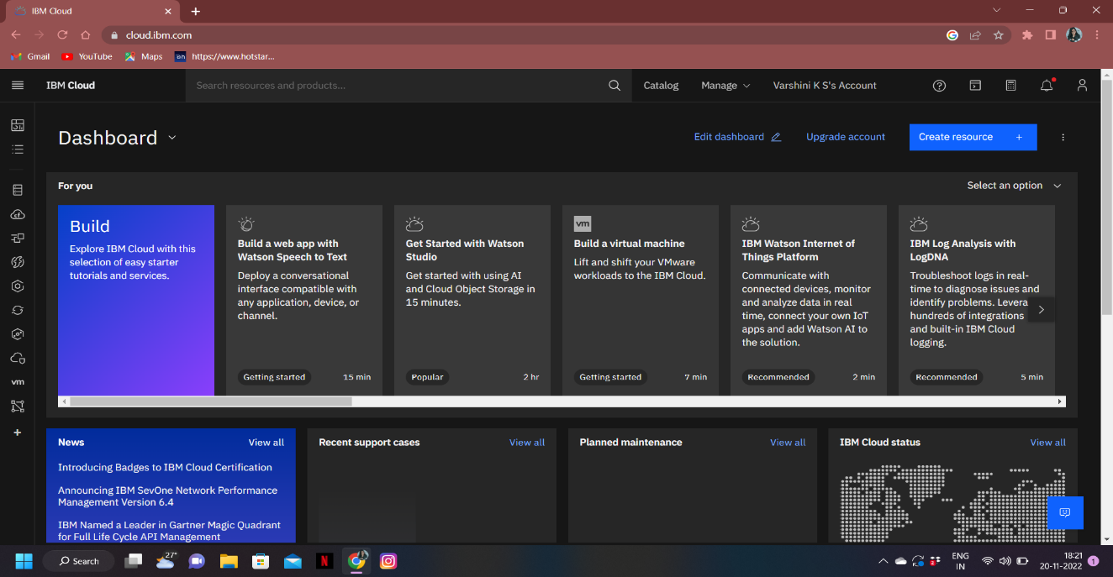

Step2:Then Go To Manage And Select Account

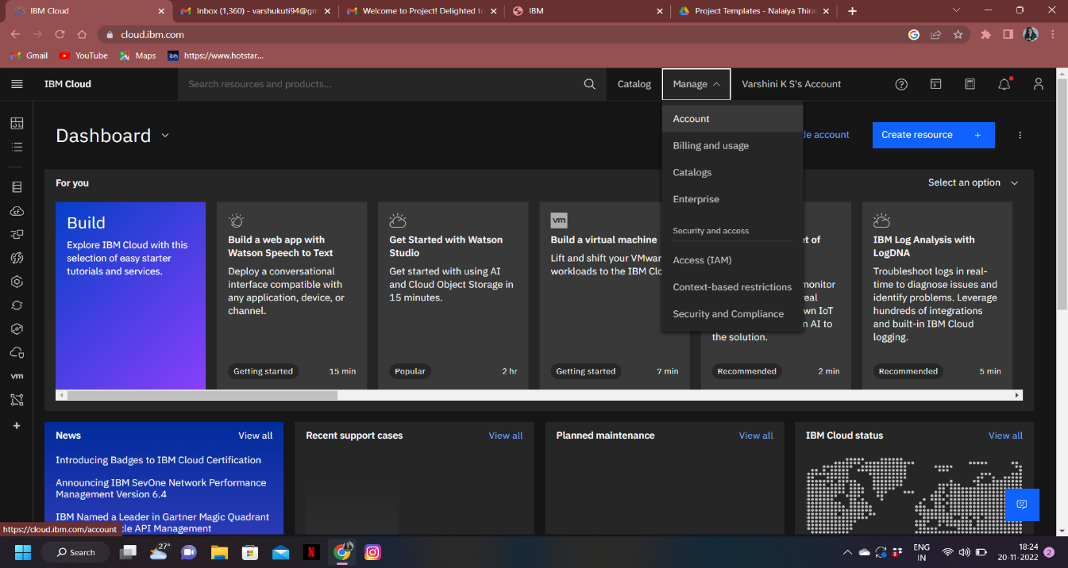

Step3:Next Go To Account Settings

